**Project README**

**Update for Milestone 2:**

Currently we are behind the schedule.

|  |  |
| --- | --- |
|  |  |
| tasks to be done | 1. Heat map 2. UI/UX 3. The main drag and drop calendar |
| tasks done | 1. Web framework design 2. Code generation 3. Import Data 4. Data handling |
|  |  |
|  |  |
|  |  |

Depending on the speed of our progress we might scrap the Chatbot module.

**Beneficiary:**

Frequent users of Calendar app/ Team Leaders/ Project Group Members

**Problem:**

Team members find it hard to locate common timeslot for meetings. Doodle does not do a good job and is hard to use. Google calendar does not have common scheduling functionality for large groups and takes a longer stretch to deliver results.

Our solution solves the problem well because the web app intuitively and instantaneously delivers common timeslots.

**User Story:**

We have done a survey on the 17 people about how good the existing apps are on finding common timeslots.

Google calendar only allows us to import other people’s schedule. It does not automatically highlight the common time periods. Nor does it abstract away occupied timeslots, thereby complicating the schedule when number of people shoot up. What’s more, the importing function of google calendar still requires us to invite other people via email. This poses an extra burden on all parties. There is no instantaneity in it.

The target group is NUS students (10) and professionals (7). Most of them are users of Google calendar (10).

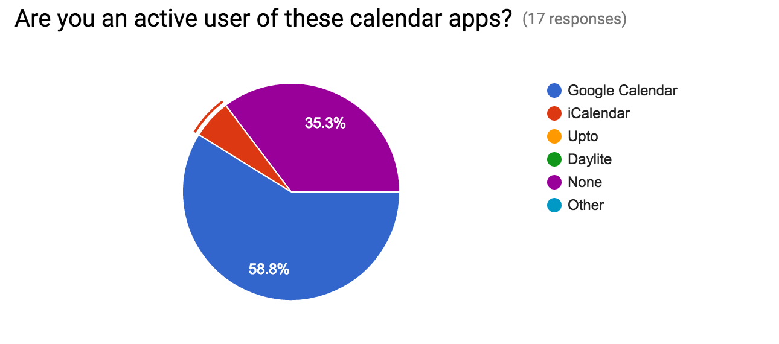

Slightly less than half of them find it a headache to schedule a common meeting time. Most of the google calendar users don’t think group scheduling is a problem.

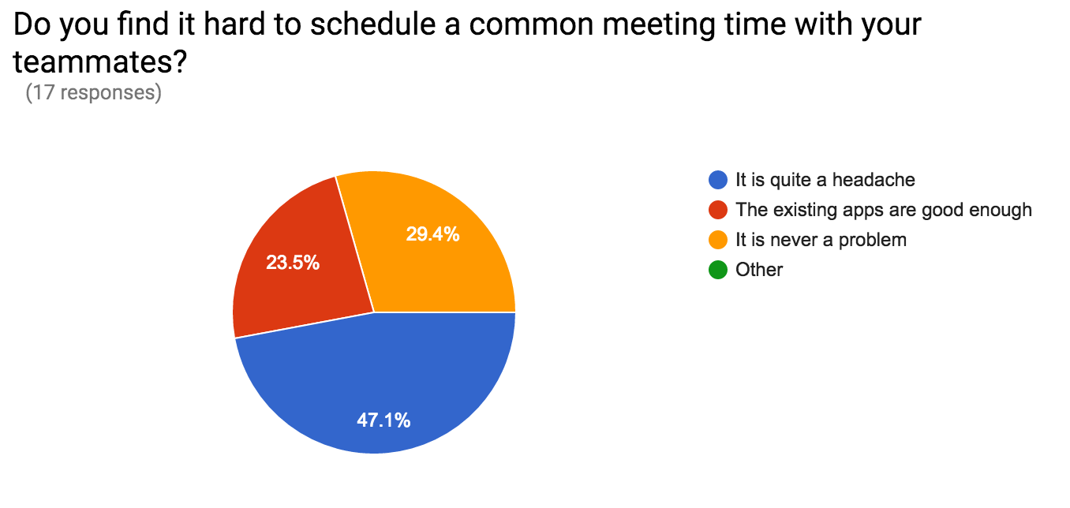

we believe that a common slot finder still helps with the scheduling task of half of NUS student’s problem.

Limitations are that the sample group is too small, thus not representative of office workers and students’ need of common scheduling. Or maybe we design the survey questions poorly and fails to reflect the acute pain of group scheduling.

Features

1. Heat Map

The web app will display the collated timetable in heat maps. More commonly shared time slots match lighter colors (like red, yellow, orange) in rainbow spectrum while occupied slots take darker, colder colors (like blue, purple or black)

1. Import and Sync

Able to import and sync with google calendar. The user can choose to login with google account and import google calendar. The results can also be exported to google calendar as events indexed by project title.

1. Live Chat

Chat function, which enables project mattes to make live coordination, or commenting on already highlighted slots.

1. Chat Bot

Chat bot, which upon request initiates a poll on chosen slots.

**Project Plan**

|  |  |
| --- | --- |
| May | Backstage data analysis (Bei Yijie)  Dealing with import data format  Project Code Generation(Jiang Hanfeng) |
| June | UI design (html 5 and CSS):  Login Page (deadline: June 10th)  The Main Drag and Drop Calendar (deadline: June 20th)  UI integration with backstage (deadline: June 30th) |
| July | Chat Bot (July 15th)  Chat Function (July 30th) |